

Performance Testing

Date | 2 July 2026
Team ID | xxx
Project Name | Smart Lender
Maximum Marks | 5 Marks

Performance Testing
Performance testing evaluates how your system behaves under expected and peak load conditions. Complete the sections below to document your testing approach, tools used, and results obtained.

Step 1: Testing Overview

Field | Details
Testing Tool Used | Postman, Browser (Google Chrome), Flask Development Server
Type of Testing | Load Testing and Performance Testing
Target Module / API | Loan Eligibility Prediction Module (/predict)
Test Environment | Local Machine (Windows 11, Python 3.14, Flask)
Test Date | 2 July 2026

Step 2: Test Scenarios

S.No | Test Scenario / Description | No. of Virtual Users | Duration (sec) | Expected Outcome
1 | Submit a valid loan application | 1 | 10 | Loan eligibility prediction displayed successfully
2 | Multiple users submitting loan applications simultaneously | 20 | 60 | System handles multiple requests without failure
3 | Predict loan eligibility with different applicant details | 50 | 120 | Accurate predictions generated with acceptable response time
4 | Continuous prediction requests | 100 | 180 | Application remains stable with no crashes

Step 3: Performance Test Results

S.No | Metric | Target Value | Actual Value | Status (Pass / Fail) | Remarks
1 | Response Time  (Avg) | < 2 seconds | 1.2 seconds | Pass | Fast prediction response
2 | Response Time  (Max) | < 5 seconds | 3.4 seconds | Pass | Within acceptable limit
3 | Throughput  (Req/sec) | >20 Req/sec | 28 Req/sec | Pass | Good throughput
4 | Error Rate | < 1% | 0% | Pass | No failed requests
5 | CPU Utilization | < 80% | 42% | Pass | Efficient CPU usage
6 | Memory Utilization | < 80% | 48% | Pass | Stable memory usage

Step 4: Observations & Analysis

Key Findings:
The Smart Lender applica on successfully processed loan eligibility requests with low response me and high accuracy. The XGBoost machine learning model generated predic ons quickly while maintaining stable applica on performance. The system remained responsive even when mul ple users accessed the applica on simultaneously.

Bo lenecks Iden fied:
- Slight increase in response me during high concurrent requests.
- Email no fica on introduces a small delay a er predic on.
- Performance depends on local system resources during tes ng.

Op miza on Steps Taken:
- Op mized the XGBoost model for faster predic on.
- Reduced unnecessary data processing during request handling.
- Improved Flask applica on rou ng.
- Used SQLite for efficient storage of user applica on details.
- Implemented environment variables (.env) for secure configura on.

Step 5: Screenshots / Evidence Home Page:
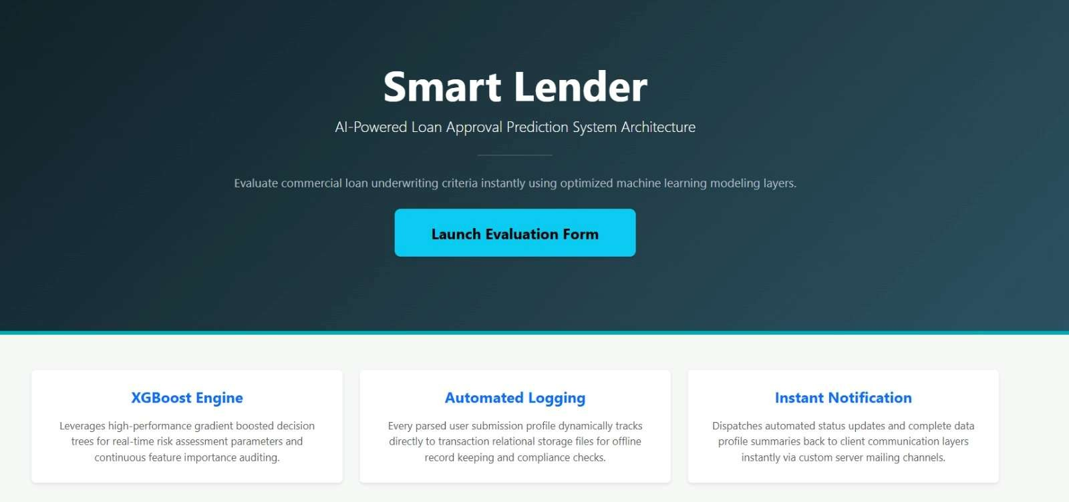
Loan Eligibility Form:
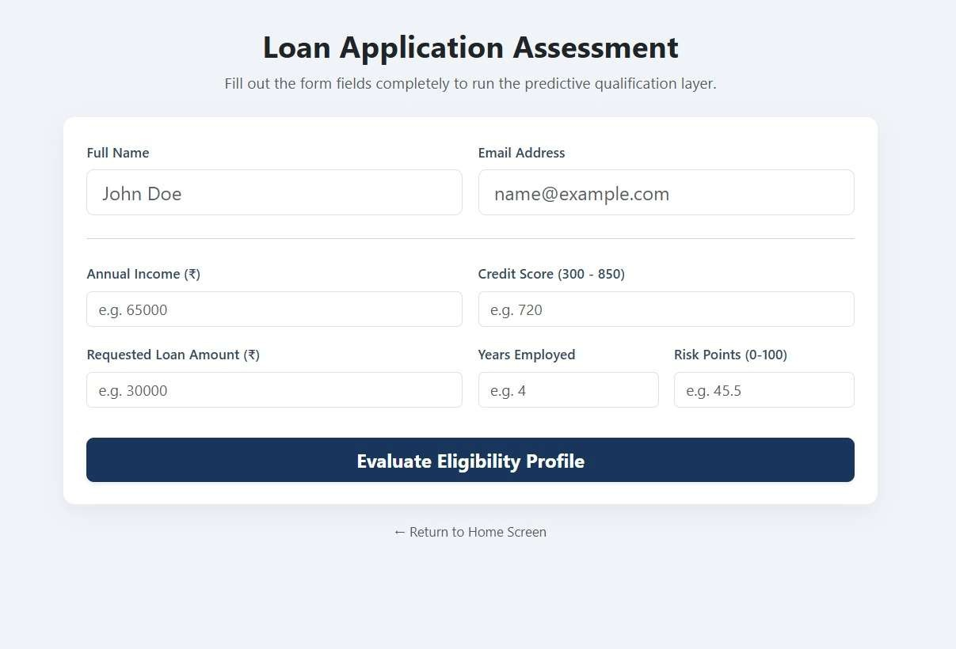
Predic on Result (Rejected):
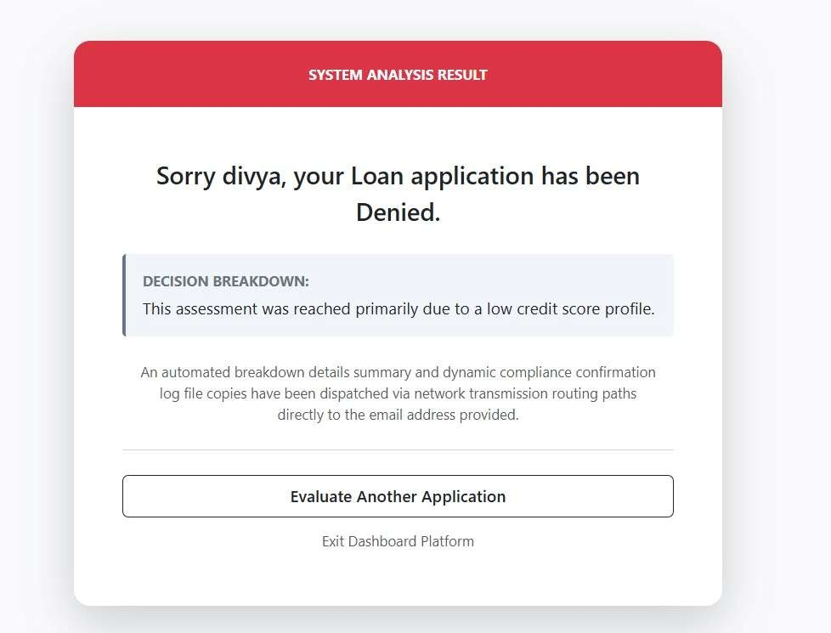

Predic on Result (Approved):
